1)Greedy approach implementation of Huffman coding
#include <stdio.h>
#include <stdlib.h>
#include <string.h>

#define MAX 20 // max number of characters

// Node structure
struct Node {
char ch;
int freq;
struct Node *left, *right;
};

// Create new node
struct Node* newNode(char c, int f) {
struct Node* node = (struct Node*)malloc(sizeof(struct Node));
node->ch = c;
node->freq = f;
node->left = node->right = NULL;
return node;
}

// Find two smallest nodes
void twoSmallest(struct Node* arr[], int n, int *x, int *y) {
*x = -1; *y = -1;
for (int i = 0; i < n; i++) {
if (arr[i] == NULL) continue;
if (*x == -1 || arr[i]->freq < arr[*x]->freq) {
*y = *x;
*x = i;
} else if (*y == -1 || arr[i]->freq < arr[*y]->freq) {
*y = i;
}
}
}

// Print Huffman codes (DFS)
void printCodes(struct Node* root, char code[], int depth) {
if (!root) return;

// Leaf node
if (!root->left && !root->right) {
code[depth] = '\0';
printf("%c : %s\n", root->ch, code);
return;
}
code[depth] = '0';
printCodes(root->left, code, depth+1);
code[depth] = '1';
printCodes(root->right, code, depth+1);
}

int main() {
int n;
printf("Enter number of characters: ");
scanf("%d", &n);

char chars[MAX];
int freq[MAX];
struct Node* arr[MAX];

printf("Enter characters: ");
for (int i = 0; i < n; i++) scanf(" %c", &chars[i]);

printf("Enter frequencies: ");
for (int i = 0; i < n; i++) scanf("%d", &freq[i]);

// Initialize node array
for (int i = 0; i < n; i++)
arr[i] = newNode(chars[i], freq[i]);

// Build Huffman tree
for (int count = n; count > 1; count--) {
int x, y;
twoSmallest(arr, n, &x, &y);

// Merge two smallest
struct Node* merged = newNode('$', arr[x]->freq + arr[y]->freq);
merged->left = arr[x];
merged->right = arr[y];
arr[x] = merged;
arr[y] = NULL;
}

// Root will be at the last non-null
struct Node* root = NULL;
for (int i = 0; i < n; i++) if (arr[i]) root = arr[i];

char code[MAX];
printf("\nHuffman Codes:\n");
printCodes(root, code, 0);

return 0;
}
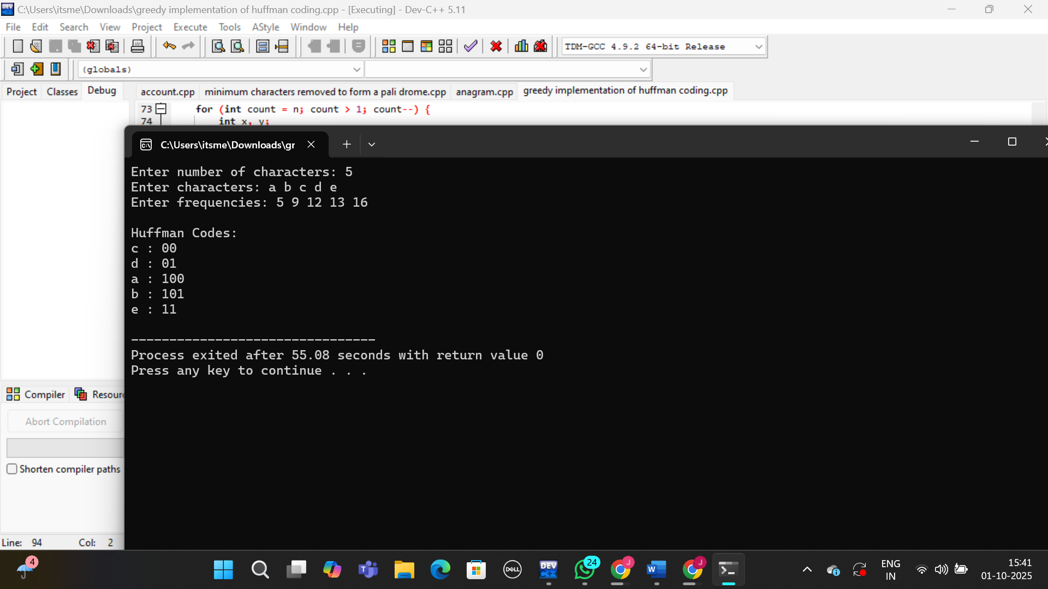

2) Assume that the numbers given below represent counts of letters in the hundreds from
a file (similar to the CLRS example). For example, in the file there will be exactly 20
* 100 occurrences of the letter ‘a’ , 11*100 occurrence of the letter ‘c’, etc.
a: 20, c:11, d:2, e: 10, o:15, m:8, s:10, t:22, u: 2
a) What is an optimal Huffman code based on the following set of frequencies?
1) Draw the tree. Show your work at every step.
2) Fill in the table on the right the Huffman encoding for each letter.
3) We encode the file using the Huffman codes produced above. How much memory will the file require with this encoding?
(a:20, c:11, d:2, e:10, o:15, m:8, s:10, t:22, u:2).

1) Build the optimal Huffman tree (showing every merge step)

Start with the symbols sorted by frequency (smallest first): d2, u2, m8, e10, s10, c11, o15, a20, t22.

Merge in ascending order:

1. d2 + u2 → node4

2. node4 + m8 → node12

3. e10 + s10 → node20

4. c11 + node12 → node23

5. o15 + a20 → node35

6. node20 + t22 → node42

7. node23 + node35 → node58

8. node42 + node58 → root node100

(Left edge = 0, right edge = 1 for code assignment.)

2) Huffman codes for each letter

From the tree above, the optimal prefix-free codes are:

t: 01

e: 000

s: 001

c: 100

m: 1011

d: 10100

u: 10101

o: 110

a: 111

3) Encoded size of the file

The statement says frequencies are in hundreds (e.g., a appears 20×100 times). Total characters = (20+11+2+10+15+8+10+22+2)×100 = 10,000.

Compute total bits = Σ(freq × code_length) × 100:

a: 20×3×100 = 6,000

c: 11×3×100 = 3,300

d: 2×5×100 = 1,000

e: 10×3×100 = 3,000

m: 8×4×100 = 3,200

o: 15×3×100 = 4,500

s: 10×3×100 = 3,000

t: 22×2×100 = 4,400

u: 2×5×100 = 1,000

Total = 29,400 bits = 3,675 bytes ≈ 3.59 KiB.

(For comparison, fixed 8-bit ASCII would be 10,000×8 = 80,000 bits = 10,000 bytes, so Huffman saves ~63%.)

